The Chesapeake Bay Dead Zone

According to the Chesapeake Bay Foundation, the Chesapeake Bay “dead zone,” areas of water with less than 5 mg/L of dissolved oxygen, comprises roughly a quarter of the mainstream waters of the bay during the summer months. The short-term low level of dissolved oxygen either kills fish and blue crabs or drives them from their preferred habitat. Less mobile species, upon which the fish and crabs feed, become stressed or die.
The low level of dissolved oxygen is a direct result of nutrient pollution, mainly nitrogen.

The figure below shows the dissolved oxygen level throughout the year for several sites along the bay. In this project we will use the exponential decay model to study the decrease in dissolved oxygen for the first half of the year for three of these sites. We will approximate the “best-fit” exponential model using the dissolved oxygen levels for January and June.

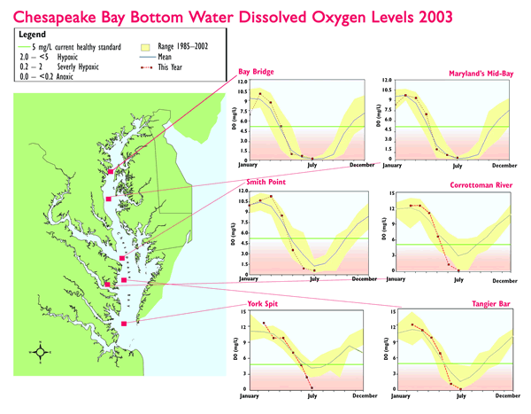
The Exponential Model

An exponential model has the form$Y={\text{ab}}^{X}$, where a is the value of Y when X=0 (sometimes called the initial value) and b is the decay factor. The decay rate, r, is calculated as 1-b and is interpreted as the proportion that is lost or removed during each time period.

Project

Find and compare the decay rates for the three sites given in the table below, which are the mean amounts of dissolved oxygen (DO) from the figure above.

Site | January DO | June DO | Decay rate
Maryland Mid-Bay  Smith Point  York Split | 9.5  10  11 | .5  .5  5

Use each of your models to predict dissolved oxygen in May. How good are these predictions?

What are some possible explanations for the differences in decay rates?

Is the exponential model appropriate for this situation? Why or why not?

What other models could be used?

Additional comparisons: What percentage of the year is the dissolved oxygen below 5 mg/L? How does the percentage change if you consider the ranges instead of the means?

The data and information for this project are from the following web site:

http://www.cbf.org/site/PageServer?pagename=resources_facts_deadzone

